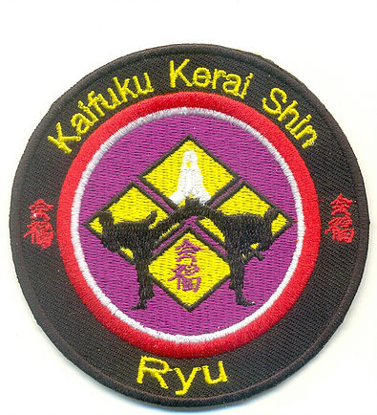
KAIFUKU KERAI SHIN RYU- KARATE CLASS

MEMBERSHIP APPLICATION

NAME: ______________________________________________ DATE: ______________________

DATE OF BIRTH (Day/Month):______________________________GENDER:___________________

HOME ADDRESS, EMAIL ADDRESS AND PHONE

______________________________________________________________________________________

______________________________________________________________________________________

______________________________________________________________________________________

INFORMED CONSENT

Dear Student, Parent and/or Legal Guardian/Student: As you are aware, the teaching of martial arts involves physical contact and the risk of injury is always a possibility. Be assured that all the reasonable precautions will be taken to insure the safety of every participant. By signing this application, you hereby agree that you have been informed of the risk of injury and waive any and all claims you might have against LJ Playpen Academy owners (Larry and Brenda Mathis and staff, Kaifuku Kerai Shin Ryu and/or instructors, and locations in Delaware, Maryland Sensei Jerome Gumbs and instructors, and Love’s Tae Kwon do Academy and her instructors, and at the New York Kaifuku Kerai Shin Ryu Headquarters under Shihan Greg Giovaniello and his instructors, and Willpower Sports and Wellness, and DC Regional Christian Church, Goldey Beacom College, or any other place we practice Kaifuku Kerai Shin.

I (do/do not) consent to have photo and video taken during class or any Kaifuku Kerai Shin functions

____________________________________ _________________________
Parent’s Signature (I f under 18 yrs old) Date

____________________________________ _________________________
Student Date

_________________________
Idris A. Clymer (Kancho-Director) Date

